Set-Var Step

Objective

Initialization is the assignment of an initial value for a data object or variable. The manner in which initialization is performed depends on the programming language, as well as type, storage class, etc., of an object to be initialized.

UI

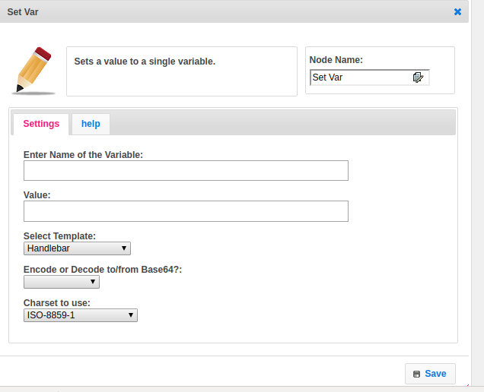

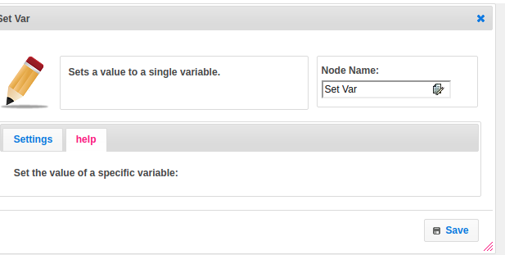

## Attributes

|  |  |
| --- | --- |
| **Attributes** | **Description** |
| **1. Enter the name of the variable** | Name of the variable. |
| **2. value** | Provide the value, which you want to store. |
| **3. Select Template** | Select Template used to set the value type.  Value types are two types.  1.hb-HandleBars  2.ftl-Freemarker Template Language. |
| **4. Encode or Decode to/from Base64?** | Base64 encoding and decoding. Base64 is a group of similar binary-to-text encoding schemes that represent binary data in an ASCII string format by translating it into a radix-64 representation. ... Base64 is commonly used in a number of applications including email via MIME, and storing complex data in XML.  Base64.Encoder presents several threadsafe instance methods for encoding byte sequences  Base64.Decoder presents several threadsafe instance methods for decoding byte sequences. |
| **5. Charset to use** | To display an HTML page correctly, a web browser must know the character set used in the page.  HTML provides different types of charsets, like few of that provided in the dropdown. Select the type based on your requirement. |

## Executor Description

Checks the value attribute contains data or not, if it contains the data then check the encode or decode attribute contains any info or not. If encode or decode have data provided by a user, based on data by using java.util.Base64 class converted to encode or decode. Encode or decode value is do nothing then it will not be converted into any other format. Finally, give the name and value as key, value respectively into the map.